CA-31
2016 IE Strategy Memorandum

Updated on 5/17/16
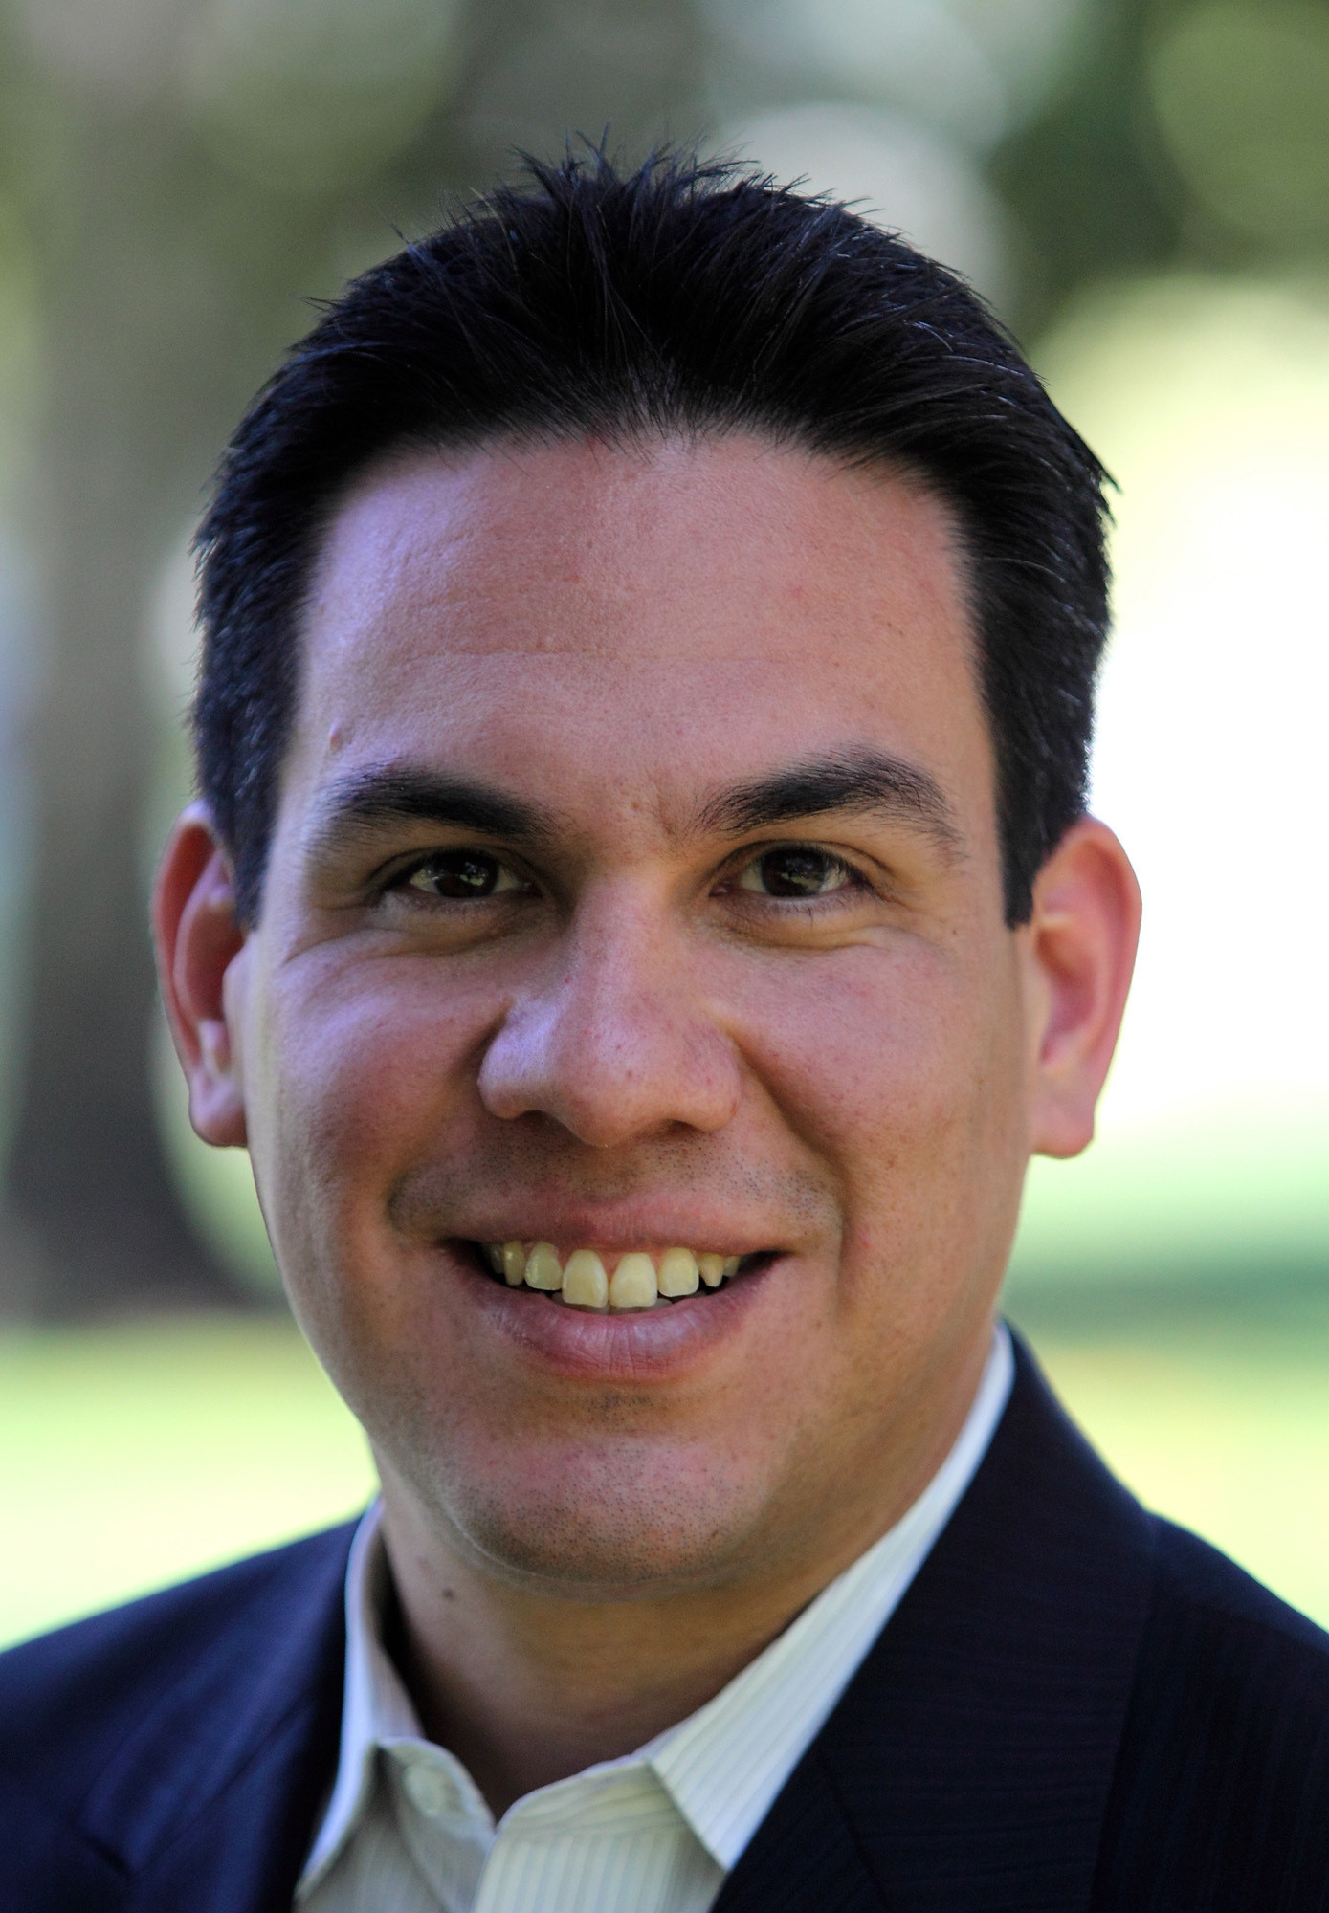
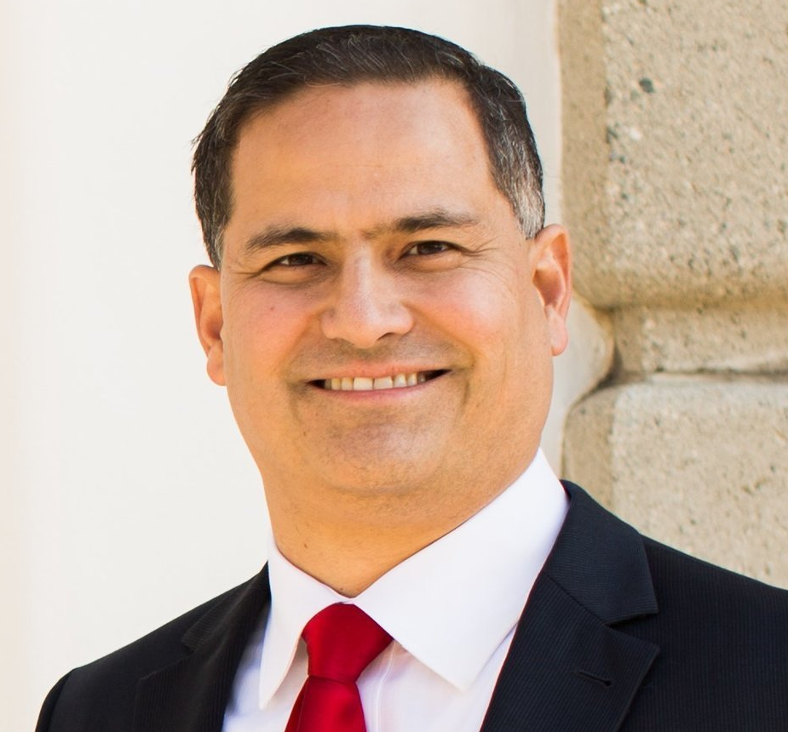

PETE AGUILAR SEAN FLYNN
CoH: $1,243,320.35 CoH: $390,390.30
Date: 4/15/16 Date: 4/15/16
Occupation: United States Representative Occupation: Economist/Businessman/Educator

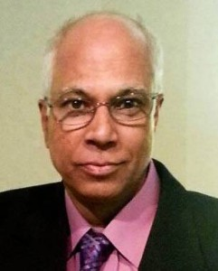
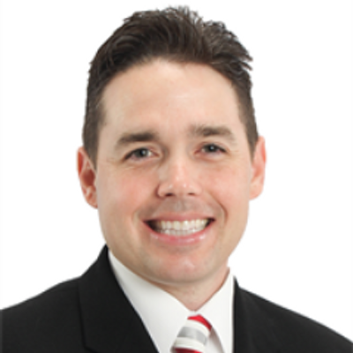

KAISAR AHMED PAUL CHABOT
CoH: CoH: $143,795.47
Date: 4/15/16 Date: 4/15/16
Occupation: Retired Educator Occupation: Counterterrorism Military Officer

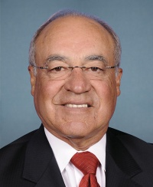

JOE BACA
CoH: $5,054
Date: 4/15/16
Occupation: Businessman/ Legislative Consultant

SECTION I: Race Overview
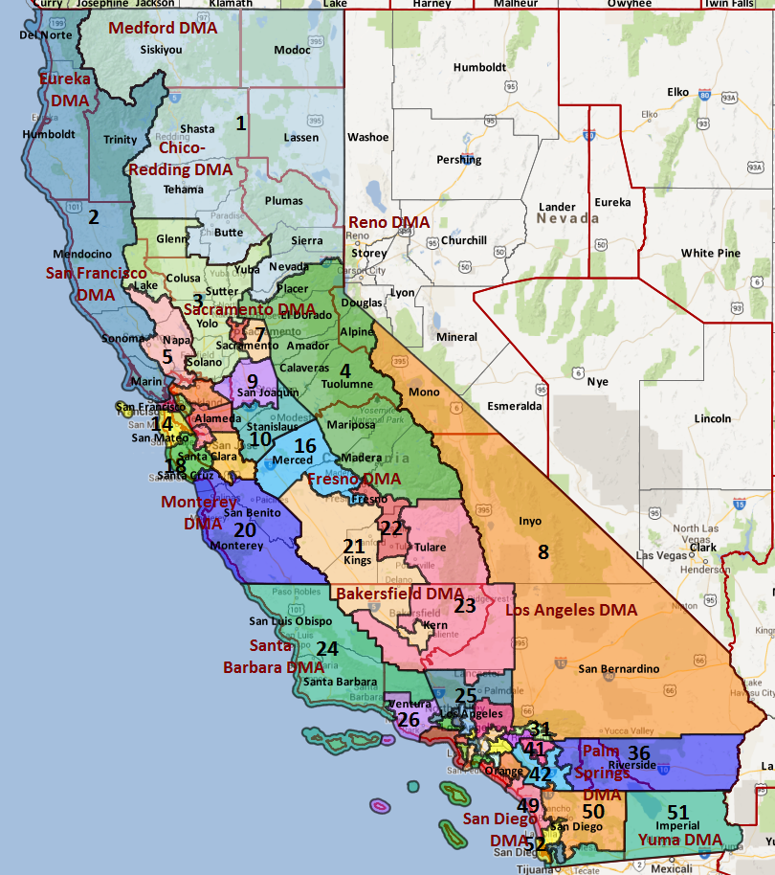

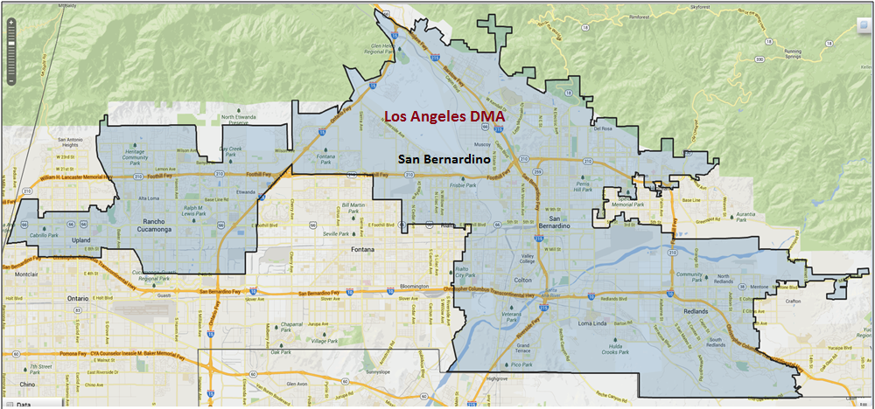

Media Market Costs

TV DMA | % of  CD | I.E.  35+ CPP | Cable CPP
LOS ANGELES | 100% | $1906 | $426
CA-31 TOTALS: | 100.0%
Radio Landscape

Riverside
Universe Size | CPP
446,500 | $370

Victor Valley
Universe Size | CPP
271,700 | $48

Digital Landscape
  - Persuasion universe size: 21,745
  - Audience extension (key demos): Hispanic, 18-55
  - Weekly budget for full coverage: $7,959.87
  - Reach
    - YouTube - 328,248
    - Pandora - 279,195

Presidential Statistics
Cycle | Candidate | Party | Vote
2012 | Obama | DEM | 58.5%
2012 | Romney | REP | 41.5%
2008 | Obama | DEM | 57.1%
2008 | McCain | REP | 42.9%

Congressional Statistics
Cycle | W/L | Candidate | Party | Vote
2014 | W | AGUILAR | DEM | 51. 7%
2014 | L | CHABOT | REP | 48.3%
2012 | L | DUTTON | REP | 44.8%
2012 | W | MILLER | REP | 55.2%

NCEC Data
Dem Performance: 55.2%
BVAP: 12.4%
Hispanic: 40.6%
Asian: 7.4%
Total Minority: 60.4%

Critical Dates
Filing Date: March 25th 2016
Primary Date: June 7th 2016

Summary of 2014 Cycle Spending by Outside Groups to Date
TV Competitive Summary – Los Angeles Cable
Campaign/Group | Total GRPs | Total Dollars
DCCC | 1,500 | $553,936
House Majority PAC | 803 | $384,419
Good Guys vs Bad Guys | Total GRPs | Total Dollars
Good Guys | 2,303 | $938,355
Bad Guys | Xxx | xxx

Summary of 2012 Spending by Outside Groups

None
Pre-Election Day Voting

Type of  “Early Voting” | Start Date  End Date | Percent of  Vote Cast Using this Method | Brief Description  (where/how  do people vote) | Timeframe (when does the majority of voting happen)
Early Vote | Oct 10 –Nov 8 |  | Voters can bring their early ballots to the board of elections office or be issued a ballot at the office at the time of their visit | Steadily between Oct 8 – Nov 7
Absentee Ballot/In person Absentee | Oct 10 – Nov 11 |  | Voters must apply for an absentee/VBM ballot via mail, online, or in person | Absentee applications must be received by BOE at least 7 days before election day
Vote By Mail | Oct 1 – Nov 11 |  | Voters must request to VBM each election unless on PEVL - VBM must be received by BOE by Nov 11 and be postmarked before election day | Ballots return steadily.

- Counties will begin sending out PAV ballots on October 10, 2016. Voters may submit a mail application to vote by mail by November 1, 2016 and can apply to vote by mail in-person thereafter. Voters can vote early at the San Bernardino County Elections Office 29 days before Election Day and later on at Montclair Branch Library.
- 60.1% of ballots were cast via mail in 2014, 47.2% of ballots were cast via mail in the 2012 election, and 43% of ballots were cast via mail in 2010.
- Mail voters in this district returned ballots at an even clip throughout the VBM period. In 2014, most ballots arrived after week three, with 24% returned before week 2, 59% returned before week 1 and 90% returned 3 days out.
- Democrats had a 2% advantage for returned ballots in 2014, however, Aguilar performed better with Election Day voters, winning 52.7% of poll ballots and 51.1% of mail ballots. Democrats started with a double-digit deficit (14%) in week four with few returned ballots, which turned into a 5% advantage at the start of week 2, a 2% advantage at the start of week 1 and a 2% advantage on Election Day.
- Looking back to the 2010 General, Republicans had a 3% advantage with returned ballots. Democrats started with a 1% advantage in week 3, a 1% disadvantage in week 2 and 2% disadvantage until the final days of the election. 39% of ballots were returned prior to week 1, with 15% of ballots in prior to week 2.
- Provided Aguilar maintains his 2014 52.7% support rate with Election Day voters and 47% of voters vote via mail, he will need to win 51.2% of vote-by-mail ballots to achieve a 52% vote goal.

SECTION II: DISTRICT OVERVIEW

- District Overview and Data

  - Political Landscape
- Two Republican candidates are challenging first-term Congressman Pete Aguilar: 2014 contender Paul Chabot and local professor Sean Flynn. A veteran and reserve Deputy Sheriff, Chabot lives in Rancho Cucamonga. NRCC recently named Sean Flynn to their Young Guns “On the Radar” program in early 2016. Two Democrats, Kaisar Ahmed and Robert Conaway, are also running.
- Per a February 2016 candidate poll, Aguilar leads Republican challenger Paul Chabot by 21 points (49% to 28%, 23% undecided), consistent with his 23 point lead over Chabot in a March 2015 candidate poll. Aguilar also outperforms the generic ballot (47% Dem to 35% Rep, 18% undecided).
- With relatively large Hispanic and African-American communities, CA-31 may see increased activity from either Democratic Senate candidate. If Loretta Sanchez makes it into the General Election, the district’s Hispanic/Latino population will be critical to her statewide path to victory.
- A February 2016 candidate poll also shows the Democratic presidential contenders are more popular than the Republican contenders. In a hypothetical head-to-head, Clinton beats Donald Trump by 17 points. Sanders (54% fav/33% unfav) is slightly more popular in the district than Clinton (50% fav/47% unfav), but both are above water, as is Marco Rubio (43% fav/38% unfav). Trump (31% fav/66% unfav) and Cruz (39% fav/44% unfav) are both unpopular with district voters.
- It is now much easier for a ballot initiative to qualify for the ballot, and we therefore expect a high number of ballot measures to appear in 2016. Ballot initiatives that may impact the electorate include:
- A “Fight for $15” minimum wage increase that is being sponsored by SEIU
- A possible initiative that will legalize the recreational use of marijuana
- A ban of the possession and sale of large ammunition clips
- Proposition 30 extensions that would continue higher income tax for the wealthiest Californians
- School Funding and Budget Stability Act that would extend Prop 30’s income tax increases through 2030 and fund K-12 education
- The “Invest in California’s Children Act,” which would impose higher rates on individual tax filers earning more than $1 million per year.
A major rule change will affect the 2016 campaign. Senate Bill 29 rules boards of elections must count absentee ballots that arrive up to three days after the election that are postmarked on or before Election Day. Previously, officials only counted ballots received by Election Day. The DMV’s new motor voter law will not be in place for the 2016 cycle.

  - District Demographics
- A majority suburban district (56.1% suburban), CA-31 is located in Southern California’s Inland Empire and is approximately 60 miles east of Los Angeles along Interstate-10. Once predominantly agricultural, the district includes the cities of San Bernardino and Rancho Cucamonga. The entire district falls in San Bernardino County.
- CA-31 is in the expensive Los Angeles media market, where the political CPP is $1,589 on average.
- CA-31 was hit especially hard by the recession (with an 18% lower average household income than the state average) and was the site of the December 2015 San Bernardino terrorist attacks.
- The district composition is extremely favorable to Congressional Democrats: Democrats hold a 6-point partisan registration advantage over Republicans (as of February 2015), and nearly 60% of citizen voting age population is minority. Latinos make up 40.6% of the district’s Citizen Voting age population and African Americans comprise 12.4% of the citizen voting age population. The district is also young, as there are 17.6% more young people (aged 18-35) in the district than seniors (aged 65+).
- California voters select a party or “decline to state” when they registered to vote. Unless otherwise noted, party names in this document reference party registration.

District Demographics

Cook Partisan Voting Index:
Urban Population: 36.6%
Suburban Population: 56.1%
Rural Population: 7.3%
Median Income: $52,396
Poverty Status: 11.9%
Military Veterans: 7.3%
Race/Ethnic Origin: 39.6% White; 12.4% Black; 7.4% Asian; 40.6% Hispanic

  - Electoral Context
- With relatively large Hispanic and African-American communities, CA-31 may see increased activity from either Democratic Senate candidate. If Loretta Sanchez makes it into the General Election, the district’s Hispanic/Latino population will be critical to her statewide path to victory.
- It is now much easier for a ballot initiative to qualify for the ballot, and we therefore expect a high number of ballot measures to appear in 2016. Ballot initiatives that may impact the electorate include:
- A “Fight for $15” minimum wage increase that is being sponsored by SEIU
- A possible initiative that will legalize the recreational use of marijuana
- A ban of the possession and sale of large ammunition clips
- Proposition 30 extensions that would continue higher income tax for the wealthiest Californians
- School Funding and Budget Stability Act that would extend Prop 30’s income tax increases through 2030 and fund K-12 education
- The “Invest in California’s Children Act,” which would impose higher rates on individual tax filers earning more than $1 million per year.
- A major rule change will affect the 2016 campaign. Senate Bill 29 rules boards of elections must count absentee ballots that arrive up to three days after the election that are postmarked on or before Election Day. Previously, officials only counted ballots received by Election Day. The DMV’s new motor voter law will not be in place for the 2016 cycle.

  - Press Presence
- LA Broadcast
- TV is nearly impossible (with the exception of crisis like the San Bernardino terrorist shootings)
- NPR/KVCR Public Radio

- Print
- Los Angeles Times - delegation reporter Sarah Wire closely followed Aguilar after the shootings
- The Los Angeles Newspaper Group owns the San Bernardino County Sun, the Inland Valley Daily Bulletin, and the Redlands Daily Facts. Stories that run in one are typically picked up by the other two papers.

SECTION III: MESSAGE

Message Box

Democrat Self Frame  I grew up in a working class family in San Bernardino. My dad was a union worker for a local utility company and my first job was working with my grandfather bussing tables. I worked two jobs in college, and with the help of Pell Grants, I was able to get a college education.  I’m running for Congress because I want to make sure every Inland Empire resident is afforded the same opportunities to climb the ladder into the middle-class and achieve the American Dream. | Republican Self Frame  I wrote Economics for Dummies, but it looks like Congress didn’t read it.  Now I’m running for office to teach Washington a thing or two about managing a successful economy.  It’s time to stop the irresponsible spending. It’s time to stop the insane debt, the staggering unemployment, the growing education costs. It’s time to bring fiscal sanity to Washington.
Likeliest Attacks on Democrat  Obama/Pelosi Democrat, voted with them XX percent of the time, supports higher taxes, defends Obamacare, not doing anything to reduce the deficit.  Supported Simpson-Bowles, which cuts defense spending, raises the Social Security retirement age, raises the gas tax, and raises overall tax rates.  Congressional perks, benefits from his time on the Redlands City Council.  Pay to play while on the Redlands City Council. | Best Attacks on Republican  Opposes abortion except in cases of rape, incest, life, or health of the woman.  Appears to not have voted in California  Said he would like to see people begin to pay for the internet, suggested paying a penny per email, and that it was preferable to giving up data and personal information.

- Pete Aguilar (D)

- Short Biography
Former Mayor of Redlands, CA. Elected in 2014. Aguilar was born in Fontana, California and grew up in nearby San Bernardino, California. Aguilar attended grade school in Yucaipa, California, and attended the University of Redlands, where he graduated with degrees in both Government and Business Administration.^{[7]} One of Aguilar's first jobs was working at the San Bernardino County Courthouse Cafeteria where his blind grandfather was the operator. He has lived in Redlands, California since 1997, with his wife Alisha. Together they have two sons.

- Self-Frame
I grew up in a working class family in San Bernardino. My dad was a union worker for a local utility company and my first job was working with my grandfather bussing tables. I worked two jobs in college, and with the help of Pell Grants, I was able to get a college education.
I’m running for Congress because I want to make sure every Inland Empire resident is afforded the same opportunities to climb the ladder into the middle-class and achieve the American Dream.

- Likely Attacks
- Obama/Pelosi Democrat, voted with them XX percent of the time, supports higher taxes, defends Obamacare, not doing anything to reduce the deficit.
- Supported Simpson-Bowles, which cuts defense spending, raises the Social Security retirement age, raises the gas tax, and raises overall tax rates.
- Congressional perks, benefits from his time on the Redlands City Council.
- Pay to play while on the Redlands City Council.

- Assessment of Democratic Fundraising

Aguilar | Q1 2015 | Q2 2015 | Q3 2015 | Q4 2015 | Q1 2016
Goal | N/A | $500,000 | $450,000 | $400,000 | $425,000
Actual Raised | $415,354 | $405,474 | $385,901 | $311,704 | $351,768

- Strengths and Weaknesses of Campaign
Rep. Aguilar has had a reputation of running lackluster campaigns and underperforming his ability, but has so far been a strong fundraiser and active presence in the district since being named as a Frontline Member working towards his first reelection.
Rep. Aguilar’s chief of staff is based in the district and is actively involved in the campaign. Rep. Aguilar has a strong team in DC, and this structure has been effective thus far.
Rep. Aguilar got significant press during the aftermath of the shooting in San Bernardino and performed well, despite having limited experience with TV press. Voters approved of the local handing of the shooting.

- Sean Flynn (R)

- Short Biography
Sean was born in 1973 on Clark Air Force base in the Philippines. After attending public schools in Los Angeles, Sean completed both a bachelor’s degree and a master’s degree in economics at the University of Southern California. Still fascinated by the economy, Sean won a scholarship to U.C. Berkeley, where he earned a doctorate in economics in 2002, studying under Nobel Laureates George Akerlof and Daniel McFadden. Sean has had a successful teaching career, first at Vassar College in New York and since 2009 at Scripps College in Claremont. Sean believes economics should always be translated into entrepreneurship and practical solutions to real problems. Author of Economics for Dummies

- Self-Frame
I wrote Economics for Dummies, but it looks like Congress didn’t read it.
Now I’m running for office to teach Washington a thing or two about managing a successful economy.
It’s time to stop the irresponsible spending. It’s time to stop the insane debt, the staggering unemployment, the growing education costs. It’s time to bring fiscal sanity to Washington.

- Best Attacks

Republican Candidate | Ryan Budget(s) – (Include if its Votes or Statement) | Privatize Social Security | Defund Planned Parenthood | Anti-Choice Position
Flynn |  |  |  | X

Flynn Top Hits
- Opposes abortion except in cases of rape, incest, life, or health of the woman. [LA Times, 2/02/16]
- Appears to not have voted in California [VAN, accessed 2/08/16]
- Said he would like to see people begin to pay for the internet, suggested paying a penny per email, and that it was preferable to giving up data and personal information. [Bald Opinions: Sean Flynn on 5 Rules to Make the Next Internet More People, accessed 2/05/16]
- Contributed nearly 11K to Democratic candidates for the Senate and House. [FEC.gov, accessed 5/04/16]
- Said ACA was a morally and ethically good idea, “no evidence” people would “actually get any healthier” [Sean Flynn: How Singapore Delivers World Class Healthcare while Spending 80 Percent Less than We Do, published 10/16/12; accessed 2/05/16]
- Said Singapore “figured out ways to actually charge the rich people more and take that money and channel it back into the poor people … let’s charge the rich people more” [Sean Flynn: How Singapore Delivers World Class Healthcare while Spending 80 Percent Less than We Do, published 10/16/12; accessed 2/05/16]
- Founded Impact Econometrics, specialized in conducting economic impact studies for development projects that seek to utilize EB-5 Visas which allow wealthy people to buy Green Cards. [EB 5 Investors, accessed 2/03/16]
- Wanted to “reinstate the sanctions on Iran that President Obama lifted without the consent of Congress” [Highland Community News, 1/28/16]
- Preferred Denmark style of education, where school principals are given power to hire and fire
- Said unionization offered a “tantalizing way to obtain the productivity gains” that otherwise occur when workers receive benefits for increased effort. [Why Only Some Industries Unionize: Insights From Reciprocity Theory, 2/14/05]

- Paul Chabot (R)

- Short Biography
Paul Chabot, age 41, is the President of Chabot Strategies, L.L.C. and Chabot Securities International. He is also an Adjunct Professor teaching American Government at California Baptist University. He is an Iraq War veteran and reserve deputy sheriff.

- Self-Frame
Chabot is a veteran and law enforcement officer who is strong on national security (would end the Iran deal and defeat ISIS) and is staunchly opposed to abortion.

- Best Attacks

Republican Candidate | Ryan Budget(s) – (Include if its Votes or Statement) | Privatize Social Security | Defund Planned Parenthood | Anti-Choice Position
Chabot |  |  |  | X

Chabot Top Hits

- Extensive and ongoing record of erratic behavior.
- Called David Axelrod an “overweight little Hitler.” [Youtube, 6/02/13]
- Opposed raising the minimum wage. . [San Bernardino Sun, 4/25/14]
- Earned over $100K per year as California Board of Parole Hearings Commissioner and defended his salary in op-ed [Governor Arnold Schwarzenegger, Official Press Release 8/20/07; San Bernardino Sun, 11/07/11]
- Described himself as a “proud Tea Party Member.” [San Bernardino Sun, 4/10/10]
- Self-published book on his failed 2014 campaign. [SBSun, 5/24/15]
- Distributed “ISIS Hunting Permit” stickers. [Roll Call, 3/03/16]
- Signed Americans for Tax Reform Pledge. [ATR Pledge, accessed 5/03/16]
- Said ““I am pro-life, pro-God and I’m not going to deviate on those. On other issues we can negotiate.” [San Bernardino Sun, 4/25/14]
- Spoke at law enforcement training group sponsored by “anti-immigration hate group.” [Times News, 8/02/12]
- Said halting illegal immigration was a top priority. [Redlands Daily Facts, 4/26/10]
- Contributed to border security bill that doubled the number of border patrol agents [Chabot Strategies, 4/12/12]
- Advocated building a wall and perimeter across the entire U.S. border. [Chabot, Archived Campaign Website, accessed 4/22/14]
- Called Arizona’s stance on illegal immigration “great,” proposed bringing Arizona-style immigration laws to California through a ballot initiative. [Redlands Daily Facts, 4/26/10]

SECTION V: Appendix

- 2016 Campaign Side Consulting Team
Media: Kully Hall Struble - lead: Hall, Kully
Mail: The Strategy Group - lead: Herman
Polling: ALG - lead: Murphy
Online/Digital: Mothership
Self-research: VR research

- Summary of Past Races and Important Differences for 2016
Recent Elections
- Obama won the district with 58.5% of the vote in 2012, a 1.3% increase from his 2008 two-way support rate of 57.1%
- CA-31 was one of the most Democratic seats in America held by a Republican when Redlands Mayor Pete Aguilar challenged Rep. Gary Miller in 2012. However, Democrats were caught off guard during the first year California’s “jungle” primary system expanded to include federal races. Mayor Aguilar finished third in the primary (by about 1,500 votes), and Republicans shut Democrats out of the general election.
- Rep. Miller announced his retirement in early 2014, which set off a contentious “jungle” primary with three Democratic and three Republican candidates. Republican Paul Chabot finished a strong first in June while the Democrats barely survived, as Mayor Aguilar outpaced Republican Leslie Gooch by 209 votes to advance to the general election. Both the DCCC and Aguilar began to communicate early post-primary, which increased Aguilar’s name-ID and began to move the needle in his favor. Chabot barely communicated on television (112 points from September 16 to October 6) and no Republican IEs played in the race, but the national environment and organic growth in Chabot’s name-ID as Election Day neared helped tighten the race considerably. In the end, Aguilar carried 51.7% of the two-way vote.
- The 2016 DPI is 55.2%, a 2.7% increase from the 2014 DPI of 52.5%.

Role of the I.E.
The DCCC IE entered the general election with a strong candidate – local Mayor Pete Aguilar – but knew we would very likely engage in this race following Paul Chabot’s strong performance in the primary and our own prior investment. Our inclination was confirmed when the benchmark showed the race clearly in play.

This district is entirely within the expensive Los Angeles market – and our early buy was on cable for six weeks (Weeks 9-4), recognizing the time needed to burn in a message. We assumed that only about half the voters were seeing our advertising anyway, given abysmal cable penetration rates in San Bernardino County.

The DCCC IE Program’s persuasion role was to define Paul Chabot as a hypocrite and anti-education: he supported deep cuts to education, while collecting for himself a large taxpayer funded salary for work on a government board that barely met. While Paul Chabot profits, kids pay the price. In this sense, we were looking to make this race about Chabot – hitting him in a factual way that is about his personal character and behavior. We also anticipated a turnout related benefit to messaging on education cuts.

We ran two ads over 6 weeks on Los Angeles Cable (Weeks 9-4) and House Majority PAC ran one ad on cable during the final 3 weeks (NOTE: HMP also dropped mail). HMP placed their ad buy before the DCCC, so we let them handle the close of the campaign. Our first ad was a studio spot that was factual (though it opened with some bells and whistles to cut through the LA cable clutter). Our second ad was a testimonial spot with a father, through which we communicated the same information in a more personal and emotional manner.

We amplified our persuasion communications through digital communications. In addition, the DCCC IE ran a separate digital communications track with the goal of increasing turnout among Hispanic and African American voters.

- Chabot Challenged Our Ads. Since Chabot intends to run again, it seems relevant to point out that he challenged our claim about his working for the parole board. In an years old op-ed, Chabot argued he worked hard and long hours. As a result,, the language we used in advertising was careful and deliberate. In his letter challenging our ads, he disagreed with our portrayal of his work on the board. Tough luck Chabot. We were able to substantiate our claims and keep the ads on the air.
- Chabot Wanted to Cut Billions in Education – More Than Just Millions. We used millions in our advertising but in hindsight could have sustained billions.

The total investment in CA-31 in the general election was $798,089.

Summary: The 2014 DCCC IE Program aired two television spots on cable in the Los Angeles Media Market with a total of 1,500 GRPs. GMMB did a shoot on September 4th and on September 6th, from which we created 2 ads. Only the first of these two ads was aired – the second was shot in case we needed to go back on air in the close.

Ads run by DCCC in CA-31

- Spot 1 – D3C14-CA31-T01 “Stage” // Los Angeles Cable (755 GRPs): Hits Chabot for taking a taxpayer salary for a government board that met once a month while calling for millions in education cuts. Notably uses footage from Chabot’s appearance on a dating show – the creative approach GMMB employed to cut through the clutter of Los Angeles cable. Studio produced.
- Spot 2 – D3C14-CA31-T02 “Sacrifice” // Los Angeles Cable (745 GRPs): Testimonial spot from a father hitting Chabot for taking a taxpayer salary for a government board that met once a month while calling for millions in education cuts. Shot in district featuring Robert Garcia and his family.

2016 Electorate
- Official Secretary of State records from 2012 indicate a turnout rate of 67.4% (206,242 votes cast).
- Applying the 2012 turnout rate of 67.4% to current voter registration as reported by the Secretary of State, we estimate a 2016 General Election turnout of 208,429 ballots cast.
- As a result, a successful re-election campaign will need 108,383 raw votes to reach a 52% support goal. A one-point shift in support equates raw 2,084 votes.
- CA-31 experienced some of the most extreme ballot roll off in the country due to the Republican-only congressional race in the General Election contest. 21.8% of voters at the Presidential level failed to vote at the congressional level and 6.1% more voters voted for a Congressional Republican than Mitt Romney.
- Party registration share has shifted slightly away from Democrats and Republicans and to Decline to State since the 2012 Election. Democratic share decreased 1.2%, Republican share decreased 0.9% and DTS share increased by 1.8%. According to Catalist’s Vote Choice History reports (VCH), we estimate White voters will comprise a smaller share of the electorate (3.2% smaller) in 2016 than the 2014 electorate.
- Using national turnout and support modeling, the Democratic base is located in the city of San Bernardino, which has a large Hispanic/Latino population, and Colton, just south of San Bernardino. Moderate communities include Upland and Fontana, in the western portion of the district. Aguilar’s hometown of Redlands has historically supported Republicans at the state and Federal level, though Aguilar’s candidacy in 2014 bumped up the city’s support level by 7 points.

DEMOCRATS START THIS RACE NARROWLY AHEAD OF REPUBLICANS BUT SHY OF THE 52% VOTE GOAL BY 857 VOTES (51.6% TWO-WAY SUPPORT). VICTORY DEPENDS ON THE FOLLOWING:
- STRENGTHEN CONNECTIONS TO THE DEMOCRATIC BASE AND RAISE AGUILAR’S PROFILE IN THE DISTRICT, INCLUDING ACHIEVING A 55.1% SUPPORT RATE WITH YOUNG VOTERS AND A 78.0% TURNOUT RATE WITH AFRICAN AMERICANS
- Maximize Latino/Hispanic turNOUT and RAISE SUPPORT TO 68.6%
- CONSOLIDATE 55.9% OF WOMEN GIVEN THE DISTRICT’S SIX-POINT GENDER GAP
- MAINTAIN support with swing Groups, including white (37%)—WHITE WOMEN (40%), White MEN (34%) — DTS (44%) and Redlands voters (42%)
- INCREASE YOUTH TURNOUT TO ABOVE 64.6%
- WIN 51.2% OF VOTE-BY-MAIL BALLOTS

